Pinball League: HardHat Zone for Play Store
Your favorite Pinball Table is now available on your Android phone!
- Photorealistic graphics
- Realistic ball physics
- Vibration feedback
- Tilt mechanics
- Portrait and landscape modes
…emerge in the world of Hardhat Zone!
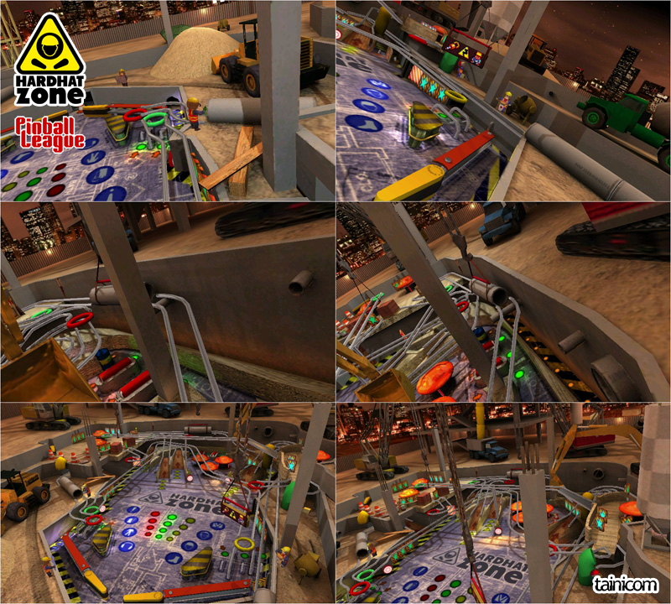
“Pinball League: HardHat Zone” is available on Play Store for €1.99!
https://play.google.com/store/apps/details?id=com.tainicom.Chervil

Pinball league: HardHat Zone
“HardHat Zone” is our third, immersive, “construction site” themed pinball table. A world full of activity, machinery and workers, cranes and bulldozers. Unlock and complete all the stackable modes, collect the bonuses and rack up your score.
Having the mobile/tablet format as a target we had unique challenges and opportunities and we opted for an equally unique approach to the game. We make sure that we design tables that everyone can enjoy playing and looking at.

tainicom
“tainicom” is an indie studio focusing primary on mobile games and applications. It was founded in 2010 by two Greek developers with many years of experience and a passion for classic gaming values.

tainicom
Athens Greece, June 22, 2019

